**CH 246: ORGANIC CHEMISTRY II LABORATORY (Spring 2021)**

**Title:**

1. **Purpose: (1 point)**

**The purpose of this experiment is to illustrate a Diels-Alder reaction using furan and maleic anhydride to make a 7-oxanorbornene derivative.**

1. **Drawing of structure of the main compound or balanced chemical equation if synthesis is performed: (1 point)**

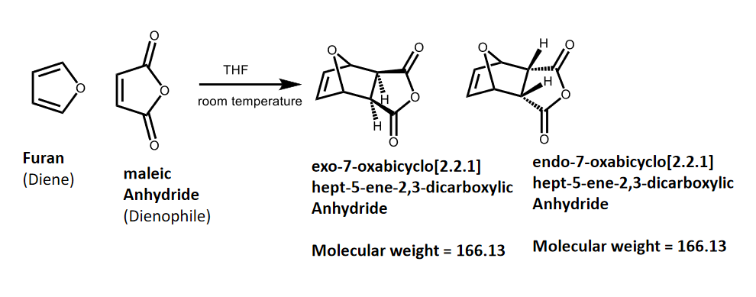

**3. Reagents and the major product (up to 5 points)**

|  |  |  |  |  |  |  |
| --- | --- | --- | --- | --- | --- | --- |
| **Name** | **M.W.**  (0.5 pts) | **Density**  (0.5 pts) | **Amount (grams/mL)**  (0.5 pts) | **Moles**  (0.5 pts) | **Hazards/Precautions**  **(MSDS data) and melting point or boiling point** (2 pts) | **Role of the reagent** (1 pts)* |
| Furan | 68.08 | 0.936 g/cm3 | 3.3 mL | 0.045 | Extremely flammable liquid and vapor. Harmful if swallowed. Causes skin irritation.  BP: 31-33°C | Reactant |
| Maleic Anhydride | 98.06 | 1.48 g/cm3 | 5 grams | 0.05 | Harmful if swallowed. Causes respiratory tract irritation and possible burns. Causes severe eye and skin irritation with possible burns.  MP: 53°C  BP: 202°C | Reactant |
| Tetrahydrofuran | 72.10 | 0.89 g/cm3 | 15 mL | 0.185 | Highly flammable. Causes eye and respiratory tract irritation.  MP: -108.5°C  BP: 66°C | Solvent |
| 7-oxabicyclo[2.2.1] hept-5-ene-2,3-dicarboxylic anhydride | 166.132 | -- | -- | -- | Causes serious eye irritation. Causes skin irritation. May cause respiratory irritation.  MP (endo): 80-81°C  MP (exo): 118-119°C | Product |

**\*** Mention role as either reactant, solvent, catalyst or product

**4. Calculations: (1 point)**

Show each calculation for moles of reagents and for theoretical and actual yield. Fill in the box with the limiting reagent and theoretical yield:

Furan

The limiting reagent is

The theoretical yield is

$$3.3 mL Furan*\frac{0.936 g Furan}{1 mL Furan}*\frac{1 mol Furan}{68.08 g Furan}*\frac{1 mol product}{1 mol Furan}*\frac{166.132 g product}{1 mol product}=7.53 g product$$

**5. Procedure (up to 2 points)**

|  |  |
| --- | --- |
| **Procedure** | **Observations and Lab Data** |
| A summary of the procedure done with bullet points) | Color changes, exothermic or endothermic reactions, gas generation, etc.; tare weights for flasks, etc. |
| * Add 5 g maleic anhydride to a 50-mL round bottom flask. * Add 15 mL tetrahydrofuran to the flask and swirl until all maleic anhydride is dissolved. * Add 3.3 mL furan to the flask and swirl for several minutes to mix contents thoroughly. * Stopper flask and allow flask to stand in laboratory conditions for 1 week. * Collect crystals through suction filtration and wash with cold THF. * Use melting point determination to determine identity of final product. |  |

**6.** Results; include actual yield in grams and % yield.

**Results (need to get signed by instructor or TA):**